**EXECUTIVE DIPLOMA IN PROCUREMENT – REGISTRATION FORM**

2026-2027 Session

Please fill-in this form (one per participant) and return it to Ms Natalia Savitcaia: [natalia.savitcaia-ext@eipm.org](mailto:natalia.savitcaia-ext@eipm.org)

Participant information

Ms  Mr First name:  Last name:

Email:  Phone:

Job title:  Company:

Address:

City:  Postal Code:  Country:

Responsible for registration

Ms  Mr First name:  Last name:

Email:  Phone:

Job title:  Company:

Address:

City:  Postal Code:  Country:

Programme structure, Scheduling & Price

Learning mode: Hybrid. The training is delivered in English

One-to-one session: 1 hr

One-week face-to-face course (x 2): 70 hrs – 9:00 AM-12:30 / 2:00-5:30 PM CEST  
Estimated duration of self-study: 19 hrs (Module 2)  
Online sessions debates & Sprints: 9 hrs (Module 2)  
Estimated duration of project development: 30 hrs (incl. 5 hrs of coaching)

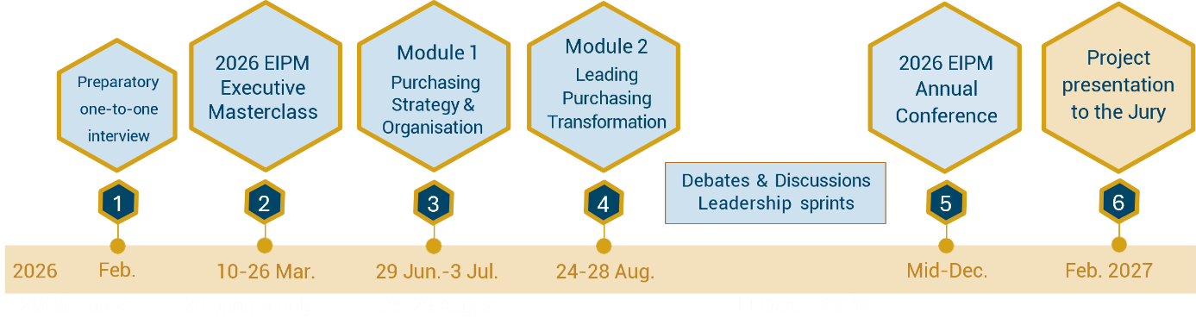

**Important note:** Entry into the cursus can take place at different steps without prejudice to the efficient running of the programme. Please contact us for more information.

|  |  |  |  |  |  |
| --- | --- | --- | --- | --- | --- |
| Step 1 | Step 2 | Step 3 | Step 4 | Step 5 | Step 6 |
| Online  one-to-one  interview | Online “Executive  Master Class” 2026 | 1st module:  1-week face-to-face courses | 2nd Module:  1-week face-to-face courses | EIPM  Annual Conference | Project  Presentation slots: |
| Date to be determined with participant | 10, 12, 17, 19, 24 & 26 March 2026  (2,5 hrs each) | Venue: Lyon-FR  29 Jun. to 03 Jul. 2026 | Venue: Lyon-FR  24 to 28 Aug. 2026 | Venue: TBC  Mid-December 2026 | Oct. 2026  Feb. 2027 |
| Tuition: | Euro 12’000  *Price is displayed free of VAT. Taxes will be calculated, if applicable, upon checkout.* | | | | |

**Invoicing information**

Company / Organisation to be invoiced:

Invoicing department contact:  Phone number:

Invoicing address:

City:  Postal Code:  Country:

**Purchase Order number** (if requested):        **European VAT number**:

**Payment**

**Bank Transfer**

**Bank transfer in euros (€) payable to:**

SAS EUROPEAN INSTITUTE OF PURCHASING MANAGEMENT

Bank: Crédit Agricole des Savoie – 2, Place de la Libération BP95 – 74160 SAINT JULIEN EN GENEVOIS – France

IBAN: FR76 1810 6000 3434 1626 7405 008 – SWIFT Code: AGRIFRPP881 – European VAT number: FR 91393094628

**IMPORTANT: Please specify the Invoice number when making the transfer**

Payment terms

* Once the invoice is issued, the Company/participant is contractually bound to pay the fees upon receipt of the invoice or 15 days before the first lesson at the latest.
* Please note that, to be admitted, all fees are due and fully payable before the starting date of a course.

Registration & Cancellation deadlines - Postponement policies

**Registration:** We recommend that you register **at least 2 weeks** before the first session of the course.  
 For late registrations, please contact EIPM by email at info@eipm.org or by telephone: +33 (0) 4 50 31 56 78.

**Absence or Cancellation by the client (Legal entity):**

* For cancellations requested **more than 15 calendar days** before the start of the training, **50%** of the training fees remain payable.
* For cancellations requested **less than 16 calendar days** before the start of the training, or in the event of the trainee’s absence, **100%** of the training fees remain payable.
* A trainee may be replaced at no additional cost, prior to the start of the programme only, by another individual from the same company.
* Once the training has commenced, no refund will be issued for any cancellation, interruption, or absence.

**Cancellation by the client (Consumer):**

* If the cancellation request is received after the withdrawal period but before the start of the training, EIPM will retain (or invoice) the deposit, except in cases of force majeure.
* Once the training has commenced, if an individual is unable to continue due to force majeure, the contract will be terminated, and the training fees will be invoiced proportionally to the portion of the program already completed.

**Postponement or Cancellation by EIPM:**

* EIPM reserves the right to postpone or cancel a training session, particularly in the event of insufficient registrations.
* Registration does not automatically guarantee that a session will be held. The session will be officially confirmed no later than:
  + **28 calendar days before the start of a face-to-face course.**
* In the event of a postponement, any amounts already paid to EIPM will be used as credit to a later session.
* In the event of a permanent cancellation, all amounts already paid will be fully refunded, unless the client agrees to transfer the registration to another session.

Related costs

* Travel, meals and accommodation expenses are not included in the training cost.

Special requirements related to the residential sessions (Step 2 & 3)

* Please note any special requirements (physical, dietary, sensory, access requirements etc.)

**Agreement**

We hereby confirm that we agree with the above terms and conditions.

**Participant Responsible for registration**

*Date*: Click here to enter a date *Date*: Click here to enter a date

*Signature: Signature:*