EXECUTIVE DIPLOMA IN PROCUREMENT – REGISTRATION FORM
2025-2026 Session
Please fill-in this form (one per participant) and return it to Ms Natalia Savitcaia: natalia.savitcaia-ext@eipm.org

Participant information
Ms Mr First name: Last name:
Email: Phone:
Job title: Company:
Address:
City: Postal Code: Country:
Responsible for registration
Ms Mr First name: Last name:
Email: Phone:
Job title: Company:
Address:
City: Postal Code: Country:
Programme structure, Scheduling & Price
Learning mode: Hybrid
One-to-one session: 1 hr
One-week face-to-face course (x 2): 70 hrs – 9:00 AM-12:30 / 2:00-5:30 PM
Estimated duration of self-study: 19 hrs (Module 2)
Online sessions debates & Sprints: 9 hrs (Module 2)
Estimated duration of project development: 30 hrs (incl. 5 hrs of coaching)
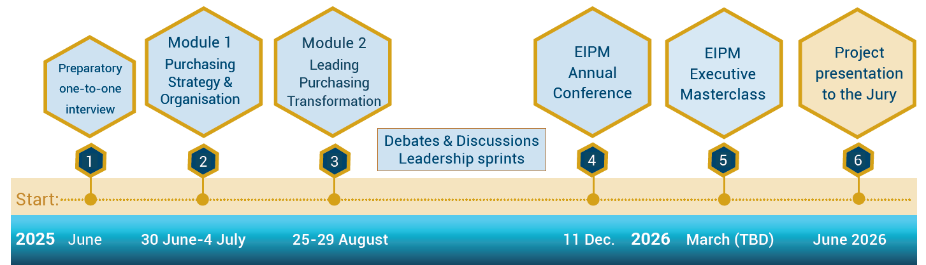

Important note: Entry into the cursus can take place at different steps without prejudice to the efficient running of the programme.
Please contact us for more information.

Step 1 | Step 2 | Step 3 | Step 4 | Step 5 | Step 6
Online  one-to-one  interview | 1st module:  1-week face-to-face  courses | 2nd Module:  1-week face-to-face  courses | EIPM  Annual Conference | Online “Executive  Master Class” 2025 | Project  Presentation slots:
Date to be determined with participant | Venue: EIPM Campus  30 Jun. to 04 Jul. 2025 | Venue: EIPM Campus  25 to 29 Aug. 2025 | Venue: TBC  11 Dec. 2025 | 11, 13, 18, 20, 25 & 27 Mar. 2026  (2,5 hrs each) | Oct. 2026  Feb. 2027
Tuition fees: | Euro 12’000  Price is displayed free of VAT. Taxes will be calculated, if applicable, upon checkout.

Invoicing information

Company / Organisation to be invoiced:
Invoicing department contact: Phone number:
Invoicing address:
City: Postal Code: Country:
Purchase Order number (if requested): ___ European VAT number:

Payment

Bank Transfer
Bank transfer in euros (€) payable to
SAS EUROPEAN INSTITUTE OF PURCHASING MANAGEMENT
Bank: Crédit Agricole des Savoie – 2, Place de la Libération BP95 – 74160 SAINT JULIEN EN GENEVOIS – France
IBAN: FR76 1810 6000 3434 1626 7405 008 – SWIFT Code: AGRIFRPP881 – European VAT number: FR 913 930 946 28

IMPORTANT: Please specify the Invoice number when making the transfer

Special requirements related to the on-site weeks (Steps 2 & 3)
Please note any special requirements (physical, dietary, sensory, access requirements etc.)

Payment terms
- Once registration is made, the Company/participant is contractually obligated to pay the fee upon receipt of the invoice.
- Please note that to be admitted, all fees are due and fully payable before the starting date of a course.

Registration & Cancellation deadlines / postponement policies
- We recommend that you register at least 2 weeks before the first session of the course. For late registrations, please contact EIPM by email at info@eipm.org or by telephone: +33 (0) 4 50 31 56 78.
- Cancellations are accepted in writing up to 15 working days prior to the scheduled course date. 50% of course fees are refundable. After that date, the full course fee is payable.
- If you cannot attend the scheduled course, we can postpone your attendance or we can accept a substitute participant.
- Under exceptional circumstances, EIPM reserves the right to postpone a course to an alternative date.
- The start of the programme will be confirmed at least 20 working days before the planned date.

General terms
- Travel, meals and accommodation expenses are not included in the training cost.

Agreement
We hereby confirm that we agree with the above terms and conditions.

Participant Responsible for registration
Date: Click here to enter a date Date: Click here to enter a date

Signature: Signature:

