EIPM CERTIFICATION – REGISTRATION FORM

Level 4: “LEADING PURCHASING TRANSFORMATION”
2024
Please fill-in this form (one per participant) and return it to Ms Natalia Savitcaia: natalia.savitcaia@eipm.org

Participant information
Ms Mr First name: Last name:
Email: Phone:
Job title: Company:
Address:
City: Postal Code: Country:
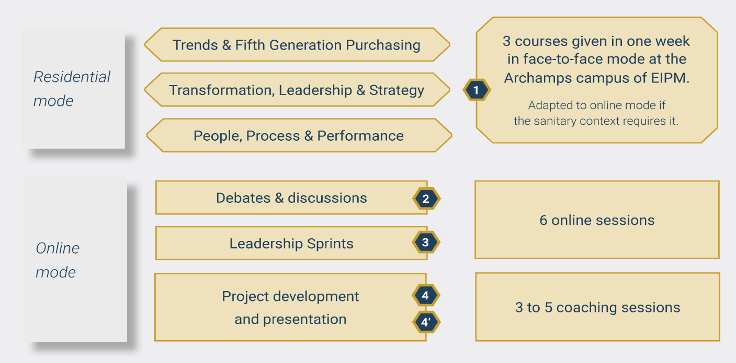
Programme structure, Scheduling & Price

 | 2
FLeX mode:  1  Cohort Residential week | Debates x 3  Online sessions | Leadership Sprints x 3  3  Online sessions | Project  4  Presentation slots
Venue:  EIPM Archamps Campus  26.08 – 30.08.2024 | 23.09.2024  04.11.2024  09.12.2024 | 14.10.2024  25.11.2024  20.01.2025 | Feb. 2025  Sep. 2025  Feb. 2026

Certification Level 4: “Leading Purchasing Transformation”
Tuition fee: EUR 7 800
Price is displayed free of VAT. Taxes will be calculated, if applicable, upon checkout.

Invoicing information

Company / Organisation to be invoiced:
Invoicing department contact: Phone number:
Invoicing address:
City: Postal Code: Country:
Purchase Order number (if requested): European VAT number:
How do you wish to make the payment?
Credit Card Credit Card type: (Diners card is not accepted)
Credit card number: / / / Security code: Expir. date:
Card holder name: ___________________________________________________

Bank Transfer
Bank transfer in euros (€) payable to
SAS EUROPEAN INSTITUTE OF PURCHASING MANAGEMENT
Bank: Crédit Agricole des Savoie – 2, Place de la Libération BP95 – 74160 SAINT JULIEN EN GENEVOIS – France
IBAN: FR76 1810 6000 3434 1626 7405 008 – SWIFT Code: AGRIFRPP881 – European VAT number: FR 913 930 946 28

IMPORTANT: Please specify the Invoice number when making the transfer

Special requirements related to the FLeX mode (Cohort residential session)
Please note any special requirements (physical, dietary, sensory, access requirements etc.)

Payment terms
- Once registration is made, the Company/participant is contractually obligated to pay the fee upon receipt of the invoice.
- Please note that to be admitted, all fees are due and fully payable before the starting date of a course.

Cancellation / postponement policies
- Cancellations are accepted in writing up to 15 business days prior to the scheduled course date. 50% of course fees are refundable. After that date, the full course fee is payable.
- If you cannot attend the scheduled course, we can postpone your attendance or we can accept a substitute participant.
- Under exceptional circumstances, EIPM reserves the right to postpone a course to an alternative date.

General terms
- Travel, meals and accommodation expenses are not included in the training cost.
- The entire course material is provided under electronic format on the EIPM learning platform.

Agreement
I hereby confirm that I agree with the above terms and conditions.

Date: Click here to enter a date

Signature:

